Section 4(ii) & (iii) | Team Structure, Experience and Qualification of the Team
3.0 | Building Service Engineer





3.1 Relevant Project Reference

3.1.1 Hotel Conversion / Renovation Projects

Project: | Renovation for Hotel Jen Hong Kong, 508 Queen's Road West
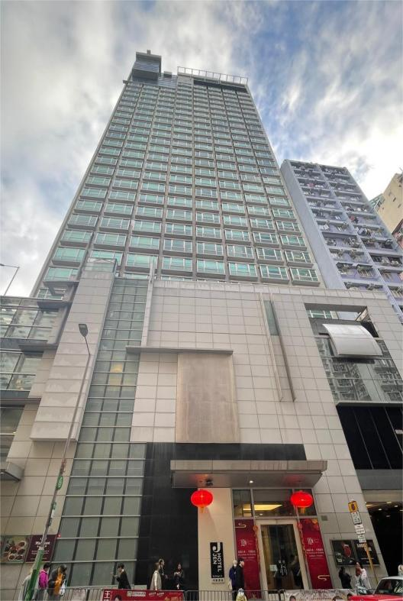
The hotel features 271 rooms. The area extend of renovation involves hotel entrance and lobby, bar/cafe/lounge, swimming pool and deck area, public circulation, guest rooms and suites. Talent carried out M&E design and project administration for hotels renovation.

Project Cost: | HK$290M (Interior + M&E)
Completion: | Apr., 2024 - Dec., 2026
Client: | Shangri-La Group

Project: | Heritage Conservation cum Hotel Dev. at  No. 179 Prince Edward Road West, Hong Kong
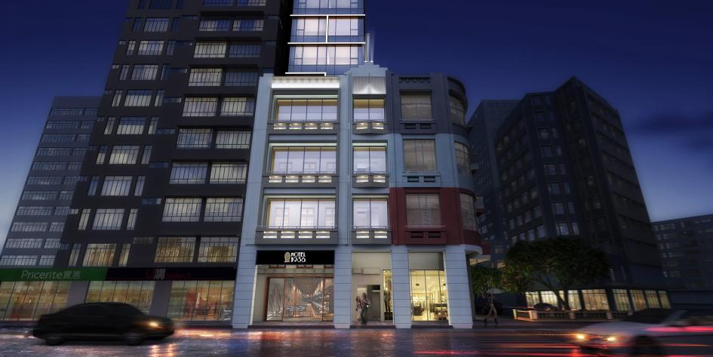
The hotel is converted from a 4-storey heritage building with facade and part of the slabs preserved. Alterations and extensions are carried out including the erection of 14-storey tower. The boutique hotel is with 50 guest rooms in the tower and retail / F&B outlets on podium floors with total floor area of 2,600m².

Project Cost: | HK$44M
Completion: | Jul., 2014 – Jul., 2018
Client: | Century Sino Development Ltd.

3.1.1 Hotel Conversion / Renovation Projects (Cont’d)

Project: | Renovation of Caritas Bianchi Lodge at Yaumatei, Hong Kong
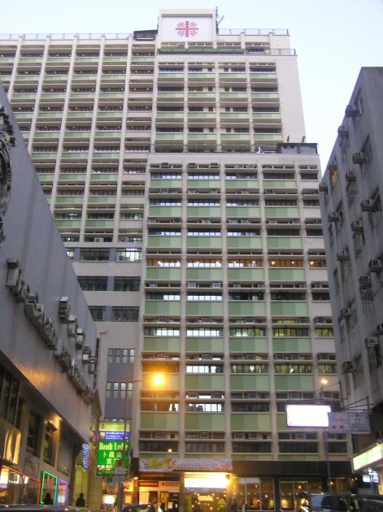
The composite building was built in the 1970's accommodating the 82 guestrooms lodge, community institute and rehabilitation workshops. The building will undergo renovation with a view to give a facelift to the building and improve its facilities to meet operation requirements.

Project Cost: | HK$25M
Completion: | Jan., 2013 - Jan., 2015 (Phase 2)  Nov., 2009 - Nov., 2011 (Phase 1)
Client: | Caritas Hong Kong

Project: | Boutique Hotel at 194-196 Queen's Road Central, Hong Kong
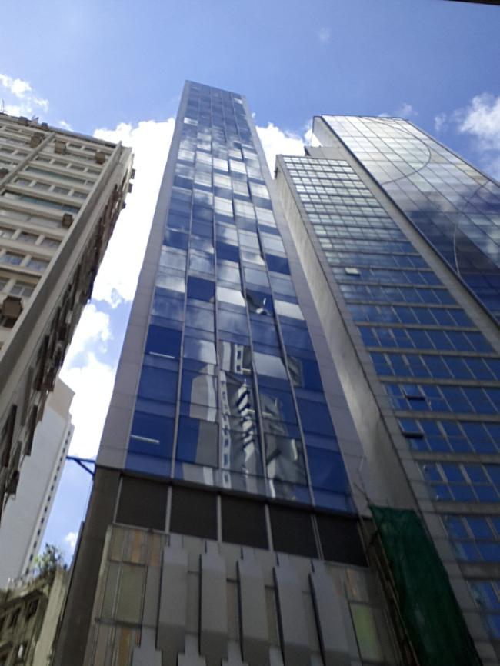
The boutique hotel is located in the heart district of the metropolitan and target at high end expertriates. Total no. of storey is 38. There are 29 guest rooms with total floor area of 1,900m².

Project Cost: | HK$8M
Completion: | Nov., 2011 - Feb., 2014
Client: | National Properties Ltd.

3.1.2 A&A Works / Refurbishment for Entire Building

Project: | Conversation of Ex-Tsuen Wan Lutheran School for  Transitional Housing at Cheung Shan Est., Tsuen Wan, Hong Kong
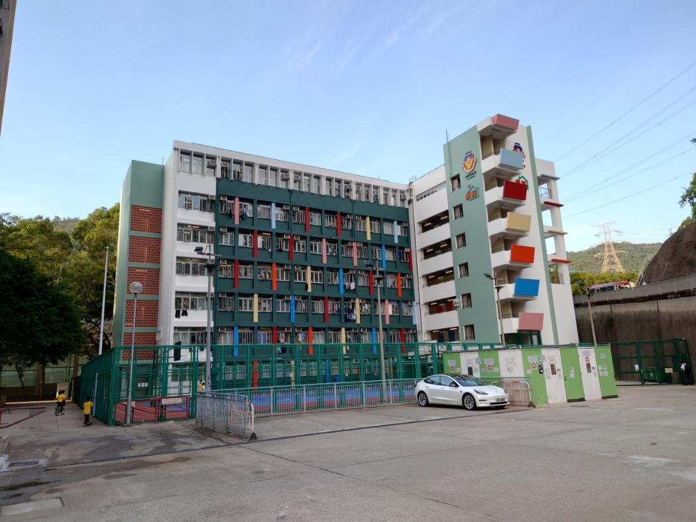
Please refer to Section 4(i)(b) Job Reference (3.0 Building Services Engineer) – Project 1 for full project description.

Project Cost: | HK$46M
Completion: | Jun., 2021 - Feb., 2023
Client: | Lok Sin Tong

Project: | Renovation Work for Wong's Factory Building at  368-370 Sha Tsui Road, Tsuen Wan, Hong Kong
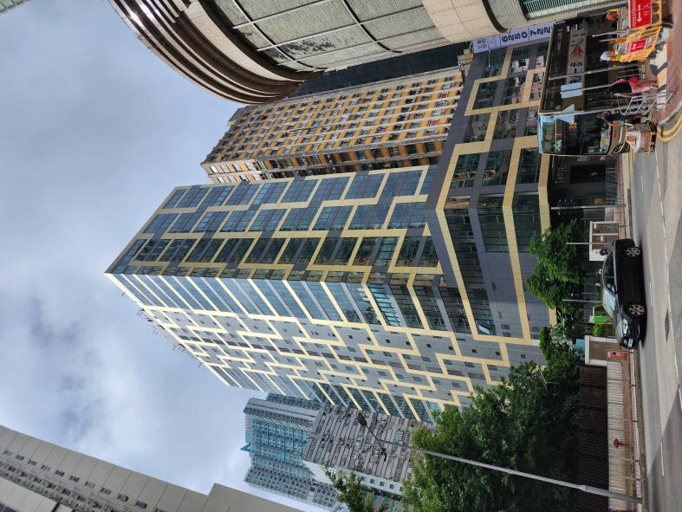
The existing building is a 23 storey industrial building with total floor area of 26,336m². This renovation works involve re-layout of units and public circulation area and enhancement of the existing facade. M&E scope includes upgrading the existing M&E system by adding new chiller plant and MVAC system, replacement / addition of fire services system, replacement / addition of lifts and escalators and the associated modification works to achieve energy efficient systems coping with the new operation needs.

Project Cost: | HK$72.8M
Completion: | Aug., 2019 - May, 2022
Client: | Tai Hung Fai Enterprise Co. Ltd.

3.1.2 A&A Works / Refurbishment for Entire Building (Cont’d)

Project: | A&A Works for Prosperity Centre, Kwai Chung, Hong Kong
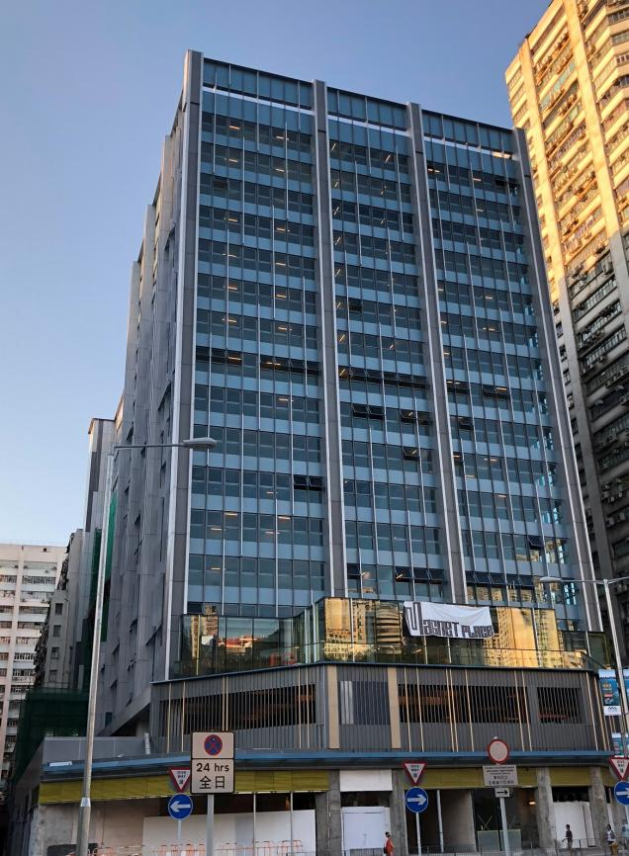
The commercial office block and shopping arcade were converted from an industrial building with floor area of 21,185m². Electrical and cooling load calculations, plant condition and configuration studies were carried out to cope with operation needs of new usages. Works included replacement of existing chiller plant and MVAC system, addition of generator set, replacement / addition of lifts and escalators and the associated modification works of other M&E services.

Project Cost: | HK$32M
Completion: | Jan., 2015 - Aug., 2018
Client: | Tai Hung Fai Enterprise Co., Ltd.

Project: | A&A Works for Yoo Hoo Tower, Kwai Chung, Hong Kong
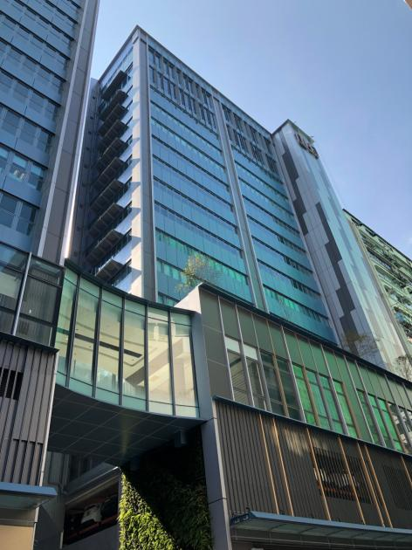
The commercial office blocks were converted from an industrial building with floor area of 12,293m². The scope of works comprised of electrical and cooling load calculations, plant condition and configuration studies to cope with operation needs of new usages. Works included replacement of existing chiller plant and MVAC system, relocation & upgrading of the existing transformer, main switch rooms replacement, addition of lifts and associated modification works of other M&E services.

Project Cost: | HK$20M
Completion: | Jan., 2015 - Dec., 2018
Client: | Tai Hung Fai Enterprise Co. Ltd.

3.2 Duties and Responsibility

The Duties and responsibility of the core personnel are as follow:

Name (Position) | Duties and Responsibility
Ho Lai Sheung, Dora  (Project Director) | - Oversee the project design, contract and finance  - Oversee the project design, contract and finance  - Overall resources management  - Attend project meetings, if need
Chu Cheuk Hang, Patrick  (Project Team Leader) | - Ensure the design team has the full support from the firm  - Overall responsible for conforming the consultant’s agreement  - Technical direction and guidance of BS design  - Focus on key issues and approach proactively on Technology  - Attend project meetings, if need  - Monthly report to Project Director
Ng Shing Pan, Bernard  (Project Engineer) | - Overall project management  - Day to day monitoring of project and point of contact with the client and project team  - Review and approval of study document  - Coordination of all task leaders of different disciplines  - Attend project & coordination meetings  - Attend meetings with other government authorities and utilities companies  - Bi-weekly report to Project Team Leader
Ng Chun Cheong, Frank  (MVAC Engineer) | - Leading and coordinating the MVAC design and specification  - Coordination and design report to Project Engineer
Kong Ming Shing, Vincent  (Electrical Engineer) | - Leading and coordinating the electrical design and specification  - Liaison with Power Company  - Coordination and design report to Project Engineer
Cheung Wai Kee, Savio  (Fire Services Engineer) | - Leading and coordinating the fire services study, design and specification  - Liaison with Fire Services Department  - Coordination and design report to Project Engineer
Cheung Wai Man, Raymond  (Plumbing & Drainage Engineer) | - Leading and coordinating the Plumbing & Drainage design and specification  - Liaison with BD / WSD  - Coordination and design report to Project Engineer


  - Organization Chart

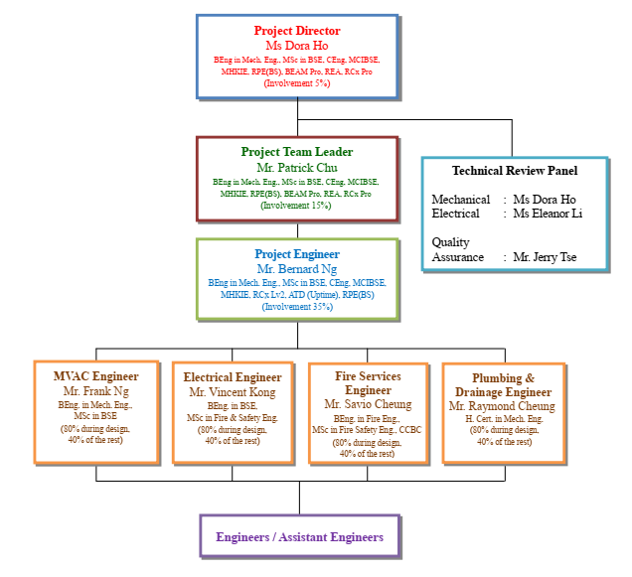

  - CV of Building Services Engineer
THE key person FOR THE DESIGN MANAGEMENT TEAM
Staff  assigned to this contract  (name) | Key person |  | Part 1 – Qualification |  | Part 2 – Experience
 |  |  | Professional Qualifications | Date of award (mm/yy) | Year of Post Qualification Experience in the capacity of the Position in this proposal | Employment Period
 |  |  |  |  |  | Company |  | Post | From  (dd/mm/yy) | To  (dd/mm/yy)
Building Services Engineer
Ho Lai Sheung, Dora | Project Director |  | BEAM Professional (NB), Hong Kong Green Building Council | 2022 | Over 15 years’ post-professional qualification experience  (i.e. MHKIE) | Talent Mechanical & Electrical Engineers Ltd. |  | Director | 2018 | Present
 |  |  | Registered Utilities Engineer (Plumbing & Drainage), Qianhai Cooperation Zone | 2021 |  |  |  | Associate Director | 2015 | 2017
 |  |  | Registered Utilities Engineer (HVAC), Qianhai Cooperation Zone | 2021 |  |  |  | Associate | 2008 | 2014
 |  |  | RCx Professional, Hong Kong Green Building Council | 2021 |  |  |  | Senior Project Engineer | 2004 | 2008
 |  |  | Registered Energy Assessor, Electrical and Mechanical Services Department (HK) | 2014 |  | Talent Mechanical & Electrical Engineers |  | Project Engineer | 2001 | 2004
 |  |  | BEAM Professional, Hong Kong Green Building Council | 2011 |  |  |  | Engineer | 1999 | 2000
 |  |  | Registered Professional Engineer (B.S. Discipline) | 2010 |  |  |  | Assistant Engineer | 1997 | 1999
 |  |  | Member, Hong Kong Institution of Engineers | 2009 |  | Sino Estates Management Ltd. |  | Assistant Engineer | 1996 | 1997
 |  |  | Chartered Engineer (UK) (B.S. Discipline) | 2008 |  | ATAL Eng. Ltd. |  | Summer Trainee | 1995
 |  |  | Member, Chartered Institution of Building Services Engineers (UK) | 2008
Chu Cheuk Hang, Patrick |  | Project Team Leader | Registered Energy Assessor, Electrical and Mechanical Services Department (HK)  (REA Reg. No. EA00966G) | 2015 | Over 15 years’ post-professional qualification experience  (i.e. MHKIE) |  | Talent Mechanical & Electrical Engineers Ltd. | Director | 2020 | Present
 |  |  | Registered Professional Engineer (BS Discipline) | 2012 |  |  |  | Associate Director | 2015 | 2019
 |  |  | BEAM Professional, Hong Kong Green Building Council | 2011 |  |  |  | Associate | 2012 | 2014
 |  |  | Chartered Engineer (UK) | 2010 |  |  |  | Senior Project Engineer | 2008 | 2011
 |  |  | Member, Chartered Institution of Building Services Engineers (UK) | 2010 |  |  |  | Project Engineer | 2005 | 2008
 |  |  | Member, Hong Kong Institution of Engineers | 2010 |  |  |  | Engineer | 2004 | 2005
 |  |  |  |  |  |  | Talent Mechanical & Electrical Engineers | Engineer | 2002 | 2004
 |  |  |  |  |  |  |  | Assistant Engineer | 2000 | 2002
Ng Shing Pan, Bernard |  | Project Engineer | Registered Professional Engineer (BS Discipline) | 2024 |  |  | Talent Mechanical & Electrical Engineers Ltd. | Associate Director | 2025 | Present
 |  |  | Member, Hong Kong Institution of Engineers | 2023 |  |  |  | Associate | 2022 | 2024
 |  |  | Accredited Tier Designer 5099, Uptime Institute | 2023 |  |  |  | Senior Project Engineer | 2017 | 2022
 |  |  | Chartered Engineer (UK) | 2022 |  |  |  | Project Engineer | 2014 | 2016
 |  |  | Member, Chartered Institution of Building Services Engineers (UK) | 2022 |  |  |  | Engineer | 2012 | 2013
 |  |  | RCx Practitioner Level 2, Hong Kong Green Building Council | 2021 |  |  |  | Assistant Engineer | 2010 | 2012

KEY PERSON FOR THE bUILDING SERVICES ENGINEER
Name of the key person: Ho Lai Sheung, Dora
Current position: Director

#Remark: (1) Similar Nature and Scope; (2) Universities, (3) Conversion, Design and Execution and completion of works at Residential Building, Hotel, Hostel; (4) Property Management at Residential building, Hotel Hostel; (5) other relevant experience
EXPERIENCE IN THE DESIGN, SUPERVISION AND COORDINATION OF CONSTRUCTION PROJECTS
COMPANY NAME | EMPLOYMENT PERIOD |  | POST | DUTIES | PROJECT TITLES | VALUE OF PROJECT ($M)  (at time of construction) | Details of experience in project (#Remark)
 | FROM  (dd/mm/yy) | TO  (dd/mm/yy
Talent Mechanical & Electrical Engineers Ltd. | 2018 | Present | Director | Ir Dora Ho has 29 years working experiences in the industry. She graduated from The University of Hong Kong in 1996 in Mechanical Engineering. She has completed the HKIE Scheme ‘A’ training in the company and obtained a Master degree in Building Services Engineering in the University of Hong Kong in 1999. She is a corporate member of CIBSE and a Chartered Engineer (UK). She is structurally trained in building services engineering and possesses job experiences in mechanical services design and project management. Her projects cover hotel, institutional, municipal, commercial and residential projects such as Renovation for Hotel Jen Hong Kong; A&A works/Renovation in HKU/ CUHK/ HKBU/ LUHK; Commercial development of One North in Yuen Long, Skyline Tower & Exchange Tower in Kowloon Bay; and residential development of Dragons Range (玖瓏山), Hermitage (帝峯．皇殿) , and etc. | Cyclical Maintenance of Kadoorie Biological Science Building, The University of Hong Kong | 58.0 | (2)
 | 2015 | 2017 | Associate Director |  | Cyclical Maintenance of 3 Dormitory Buildings, 6 Sassoon Road, The University of Hong Kong | 60.0 | (2)
 | 2008 | 2014 | Associate |  | Hotel Jen Hong Kong (Shangri-La), Western District, H.K. | 290.0 | (3)
 | 2004 | 2008 | Senior Project Engineer |  | Boutique Hotel at 194-196 Queen’s Road Central, H.K. | 8.0  (M&E) | (3)
Talent Mechanical & Electrical Engineers | 2001 | 2004 | Project Engineer |  | Residential Development at STTL 525, Kau To Shan, Shantin, H.K. | 460.0  (M&E) | (3), (5)
 | 1999 | 2000 | Engineer |  | The Hermitage, KIL 11167 & 11168, West Kowloon, H.K. | 350.0  (M&E) | (3), (5)
 | 1997 | 1999 | Assistant Engineer |  | Proposed A&A Works for Garden Bakery, Sham Shui Po, H.K. | 24.4  (M&E) | (5)
Sino Estates Management Ltd. | 1996 | 1997 | Assistant Engineer |  | A&A Works for Prosperity Centre and Yoo Hoo Tower, Kwai Chung, H.K. | 20.0  (M&E) | (5)
ATAL Eng. Ltd. | 1995 |  | Summer Trainee

NAME | PROJECT TITLES | Past Performance Record
Ho Lai Sheung, Dora | - Shaw Campus Entrance Hong Kong Baptist University | The Hong Kong Institute of Architects (HKIA) Special Award 2024 - Finalist (Interior Design)
 | - Crop Science Laboratory Hong Kong Baptist University | The Hong Kong Institute of Architects (HKIA) Special Award 2023 - Finalist (Heritage & Adaptive Re-use)  Hong Kong Green Building Award 2023 - Finalist (Completed Projects – Institutional Building)

SUPPORTING TEAM FOR THE bUILDING SERVICES ENGINEER

Name of the key person: Chu Cheuk Hang, Patrick
Current position: Director

#Remark: (1) Similar Nature and Scope; (2) Universities, (3) Conversion, Design and Execution and completion of works at Residential Building, Hotel, Hostel; (4) Property Management at Residential building, Hotel Hostel; (5) other relevant experience
EXPERIENCE IN THE DESIGN, SUPERVISION AND COORDINATION OF CONSTRUCTION PROJECTS
COMPANY NAME | EMPLOYMENT PERIOD |  | POST | DUTIES | PROJECT TITLES | VALUE OF PROJECT ($M)  (at time of construction) | Details of experience in project (#Remark)
 | FROM  (dd/mm/yy) | TO  (dd/mm/yy
Talent Mechanical & Electrical Engineers Ltd. | 2020 | Present | Director | Ir Chu graduated from the HKUST in 2000 studying B.Eng. in mechanical engineering and from the University of Hong Kong in 2005 for M.Sc. in BSE. He has 26 years experiences in the industry. He has been participating in various kinds of projects focusing on design and project administration covering offices, residential, institutional, and A&A projects. Projects include Commercial Development at 18 Wang Chiu Road in Kowloon Bay; Residential development of Victoria Skye (天寰), Mont Rouge (緹山); A&A works for Link’s Temple Mall North and South; Renovation Works for NGOs/ Institutional organization. | Caritas Bianchi Lodge at Yaumatei, H.K. | 25.0  (M&E) | (3)
 | 2015 | 2019 | Associate Director |  | A&A Works for Boutique Hotel at 21-23A Prat Avenue, Tsim Sha Tsui, H.K. | 15.0  (M&E) | (3)
 | 2012 | 2014 | Associate |  | A&A Works for Boutique Hotel at 35-39 Morrison Hill Road, Wanchai, H.K. | 13.0  (M&E) | (3)
 | 2008 | 2011 | Senior Project Engineer |  | Conversion of Ex-Tsuen Wan Lutheran School for Transitional Housing at Cheung Shan Estate, Tsuen Wan, H.K. | 46.0 | (3)
 | 2005 | 2008 | Project Engineer |  | Proposed Resident Development at TMTL 549, Junction of King Sau Lane and King Fung Path, Tuen Mun, H.K. | 35.0  (M&E) | (3), (5)
 | 2004 | 2005 | Engineer |  | Residential Development at NKIL No. 6525 Kai Tak, Kowloon, H.K. | 370.0  (M&E) | (3), (5)
Talent Mechanical & Electrical Engineers | 2002 | 2004 | Engineer |  | ArchSD Modernisation of Aberdeen Market cum Cooked Food Centre (Consultancy Agreement No. 9AH106) | 244.6 | (5)
 | 2000 | 2002 | Assistant Engineer

SUPPORTING TEAM FOR THE bUILDING SERVICES ENGINEER

Name of the key person: Ng Shing Pan, Bernard
Current position: Associate Director

#Remark: (1) Similar Nature and Scope; (2) Universities, (3) Conversion, Design and Execution and completion of works at Residential Building, Hotel, Hostel; (4) Property Management at Residential building, Hotel Hostel; (5) other relevant experience
EXPERIENCE IN THE DESIGN, SUPERVISION AND COORDINATION OF CONSTRUCTION PROJECTS
COMPANY NAME | EMPLOYMENT PERIOD |  | POST | DUTIES | PROJECT TITLES | VALUE OF PROJECT ($M)  (at time of construction) | Details of experience in project (#Remark)
 | FROM  (dd/mm/yy) | TO  (dd/mm/yy
Talent Mechanical & Electrical Engineers Ltd. | 2025 | Present | Associate Director | Ir. Bernard Ng has 16 years working experience in the industry. He graduated from The Hong Kong University of Science and Technology in 2010 studying Mechanical Engineering. He has completed the HKIE Scheme “A” training in the company and obtained a Master Degree in Building Services Engineering from the University of Hong Kong in 2014. He has experience on design and handling of wide range of projects. His projects cover hotels, shopping centres, office buildings, residential projects and data centres including Hotel Jen Hong Kong, Shangri-La Hotel in Diqing, Tenova Future Project Shenzhen, Residential Development at NKIL 6525 in Kai Tak etc. | Residential Development at TMTL549, King Sau Lane, Tuen Mun, H.K. | 35.0  (M&E) | (3), (5)
 | 2022 | 2024 | Associate |  | Residential Development at NKIL 6525 Kai Tak, Kowloon, H.K. | 370.0  (M&E) | (3), (5)
 | 2017 | 2022 | Senior Project Engineer |  | Residential Development at 1 Ede Road, Kowloon Tong, Kowloon, H.K. | 52.0  (M&E) | (3), (5)
 | 2014 | 2016 | Project Engineer |  | Proposed Commercial Development at No. 49-51 Kimberley Road, Tsim Sha Tsui, H.K. | 63.4  (M&E) | (5)
 | 2012 | 2013 | Engineer
 | 2010 | 2012 | Assistant Engineer

